Ethernet Over Coaxial (EoC)
Network Management System Software

User Manual

Content
Guide
About this Manual
Format of this Manufal
1.EoC NMS Network Management Configuration Environment 2
1.1 Configuration Environment Picture 2
1.2 Configuration Environment Procedure 2
1.3 Attention Points 3
2.EoC NMS Network Managemnet Configuration Description 4
2.1 Original Settings 4
2.1.1 Original Interface 4
2.1.2 Original Global Configuration 5
2.2 Network Element Found 6
2.2.1 Single Network Element Found 6
2.2.2 Network Discovery 8
2.3 Master Configuration Interface 10
2.3.1 Master Equipment Property 10
2.3.2 Configuration Management 11
2.3.2.1 General Management Interface 12
2.3.2.2 VLAN Management Interface 12
2.3.2.3 QOS Management 13
2.3.2.4 MAC White Forms Management 13
2.3.2.5 IP Access Control 14
2.3.2.6 TrapServer 14
2.3.2.7 Operation Management 14
2.3.3 Maintainance Management 15
2.3.4 Fault Management 15
2.3.5 Performance Management 16
2.3.6 Check Operation Log 18
2.3.7 Default Setting of Slaver 19
2.3.8 Lead-out Configuration Data 19
2.3.9 Delete Master’s Operation 19
2.4 End-user（Slaver）Configuration Page 20
2.4.1 Slaver Equipment’s Property 20
2.4.2 Slaver’s Configuration Management 21
2.4.2.1 General Management 22
2.4.2.2 VLAN Management 23
2.4.2.3 QoS Management 25
2.4.2.4 Broadcast Storm Control 25
2.4.2.5 MAC Limiting Management 26
2.4.2.6 Operation Management 26
2.4.3 Slaver’s Maintainance Operation 26
2.4.4 Delete Slaver 27
2.4.5 Slaver Exchange 27
2.5 Checking Master and Slaver 28
2.5.1 Slaver Checking 28
2.5.2 Master Checking 28
2.6 Alarm and Events 30
2.6.1 Alarm 30
2.6.2 Events 31
2.7 Performance Management 32
2.8 Safety Management 35
2.8.1 Basic Information 35
2.8.2 Change Password 35
2.8.3 Users’ Management 36
2.8.4 Group Management 37
2.8.5 Checking Log 38
2.9 System Setting 40
2.9.1 System Parameter’s Setting 40
2.9.2 Locate Setting 40
2.9.3 Template Function 41
2.9.4 Complete Configuration 42
2.9.5 Pre-configuration for Slaver 42
2.9.6 Database Backup and Restore 43
2.9.6.1 Backup Database 43
2.9.6.2 Restore Database 43
2.9.6.3 Data Migration 43
2.9.7 Master Upgrade 44

Guide

About this Manual

The content of this Manual as follows:

·Chapter 1: EoC NMS Configuration Environment. Introduce EOC Master and Slaver’s configuration environment and the basic operation when configuring.
·Chapter 2: EoC NMS Configuration description. Introduce EOC Master and Slaver’s configuration method and how to use it.

Format of this Manual
The format description as follows:
Format | Description
< > | “< >” means Button, for example: Click<confirm> Button
[ ] | “[ ]” means window, menu, data form, for example: pop-up[confirm]

1.EoC NMS Management Configuration

1.1 Configuration Environment Picture
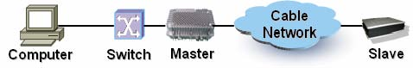
Pic.: 1.1 EoC NMS Network Configuration Environment Figure.
As in the figure, confirm the network connection of Master and Slaver, connect Master with Switch, uplink with Management PC, then finish the configuration.

1.2 Configuration Environment Procedure
Step one: Double click the short-cut icon “Start Server”, open server, when appears “mysql-eoc” means service started successfully. As figure 1.2.1.

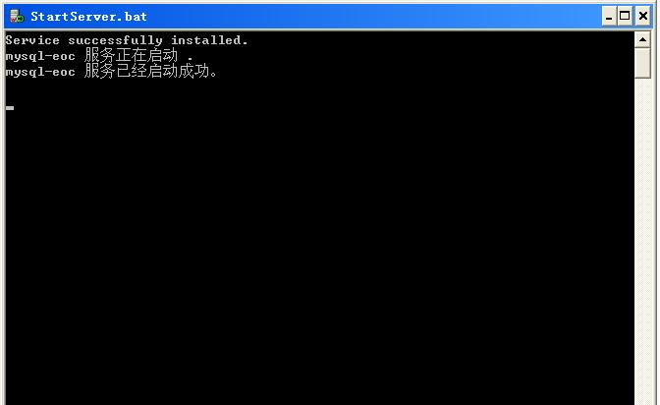
Figure 1.2.1 Start Server

Step two: Open IE, and input http://localhost:8080/ems/jsp/login.jsp or http://server ip address:8080/ems/jsp/login.jsp/ open network login page. As figure 1.2.2
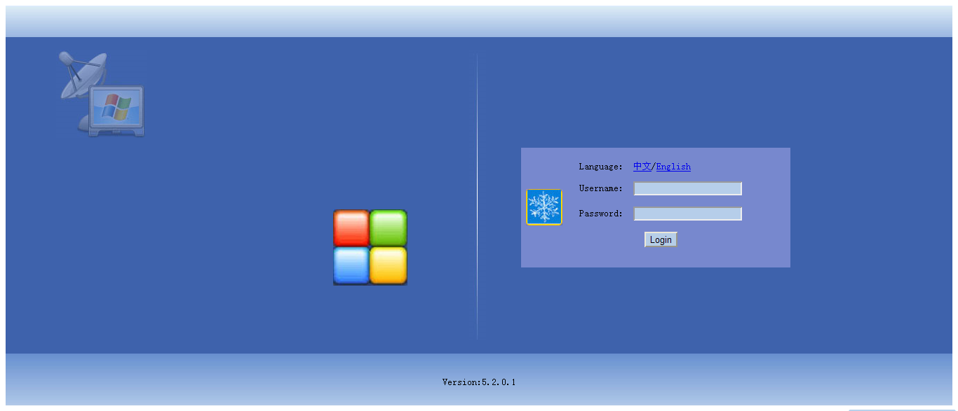
Figure 1.2.2 Login Page
Step three: Follow the Login Page, fill in “User Name” and “Password”, click <login>, then entered EOC NMS Interface. Default User Name: “root”, Password: “root”.

1.3 Attention Points
1. EoC NMS use general computer and server as hardware platform;
2. System memory must be above 512M;
3. EoC NMS use Windows 2000, Windows XP and other network supported operation system;
4. Computer must install and start TCP/IP protocol;
5. When setting local configuration, make sure the computer’s IP address and Master’s IP address must be in same sub-network before visiting EOC NMS. Default Master IP Address:192.168.0.254, sub-network mask code: 255.255.255.0。

2. EoC NMS Network Management Configuration Description

2.1 Original Setting

2.1.1 Original Interface
EoC NMS page include five area:（1）Functions area,（2）Network Element manage area,（3）Configuration area,(4)Alarm Statistics area,(5)Latest Alarm area. Click Guide menu can enter relative function configuration, Configuration area will show the status information of Guide, and can change it’s configuration.
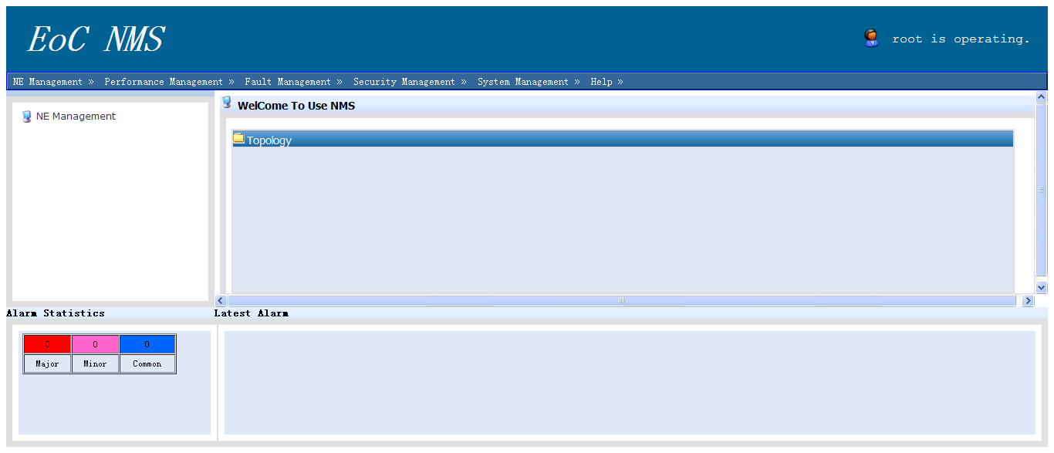
Figure 2.1.1 EoC NMS Network Management Original Interface

2.1.2 Original Global Configuration
Under topological tree’s of Guide area, click 【System Setting】->【Global Configuration】，enter the interface 2.1.2.
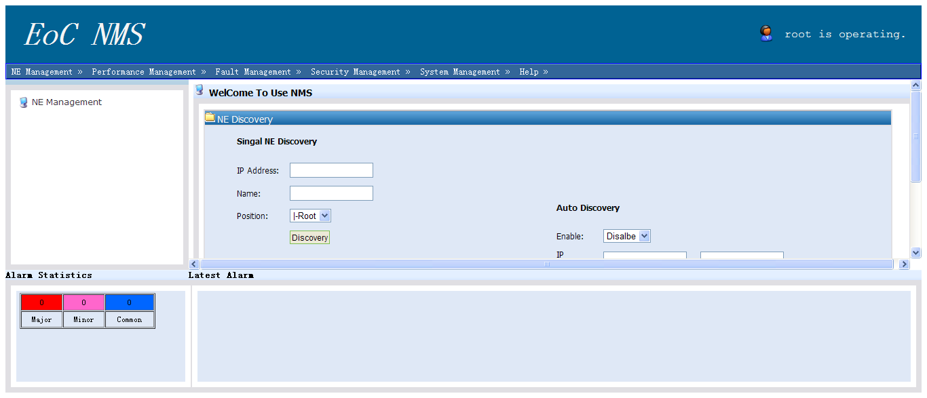
Figure 2.1.2 Original Complete Configuration
Note: When start with global configuration function, after discovered Master in Network Element Found transmit the configuration interface data to Slaver’s default configuration, and change it once new Slaver entered.

2.2 Network Element Found
Click the【Network Element Found】at left side in Guide area, enter Network Element Found Page. As Figure 2.2.1, can found Master through Network Element Found. It includes: single network element found and network discovery.
Figure 2.2.1 Network Element Found Interface

2.2.1 Single Network Element Found
Operation Steps:
1. Input Master’s IP address which needs management. (origin IP: 192.168.0.247)
2. Equipment Name can named by the actual situation. Network Management will default the IP Address of the Master as the name.
3. The original status of the setting area is root code, it can be adjustable by actual situation.
4. Then double click【Found】button, it will appear figure 2.2.2
5. Double click Master, it will be showed the Slaver’s status picture belongs to the Master. As Figure2.2.3

Figure 2.2.2 Network Element added successfully
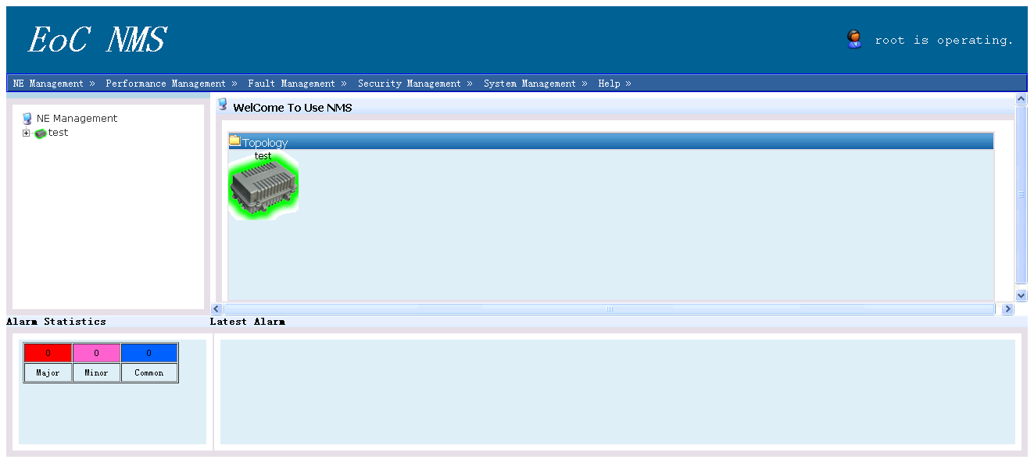

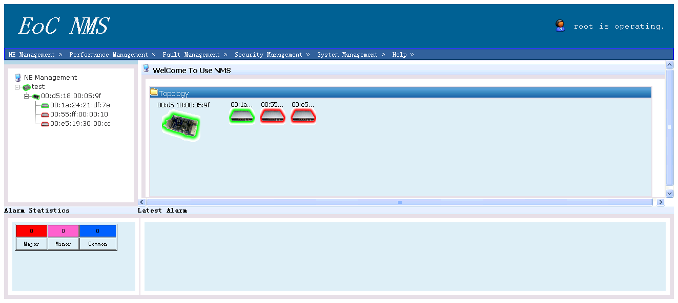
Figure 2.2.3 Slaver’s status under connected Master

2.2.2 Network Discovery
Operation Steps:
1. Input the Network Segment’s start IP and finish IP which need to be found in the equipment’s IP of【Network Segment Found】
2. The original status of the setting area is root code, it can be adjustable by actual situation.
3. Then Click【Found】button, it will appear figure 2.2.4 interface
5. Click【Back Topology】, enter into main topology. As figure 2.2.5
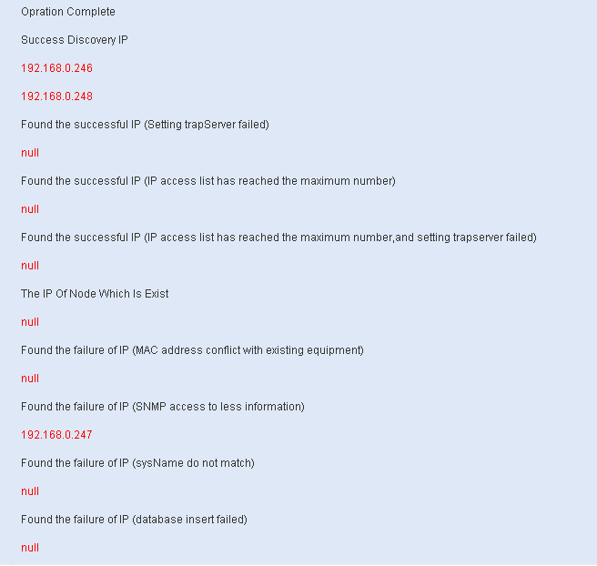
Figure 2.2.4 Result of Network Segment Found
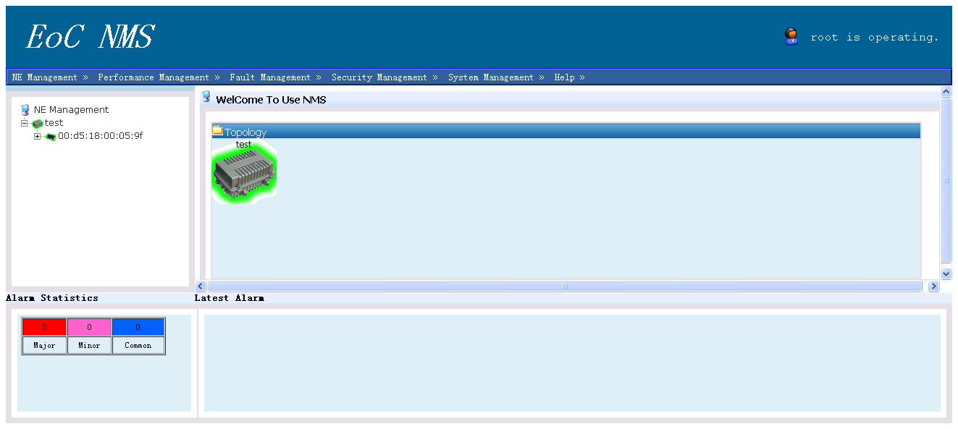
Figure 2.2.5 Network Segment found main topology

2.3 Master’s Configuration Interface
Use right click the Master which need to be managed. As Figure 2.3, can setting followings for Master:
Performance info
Threshold setting
Cnu default
Manual
WEB management
Delete
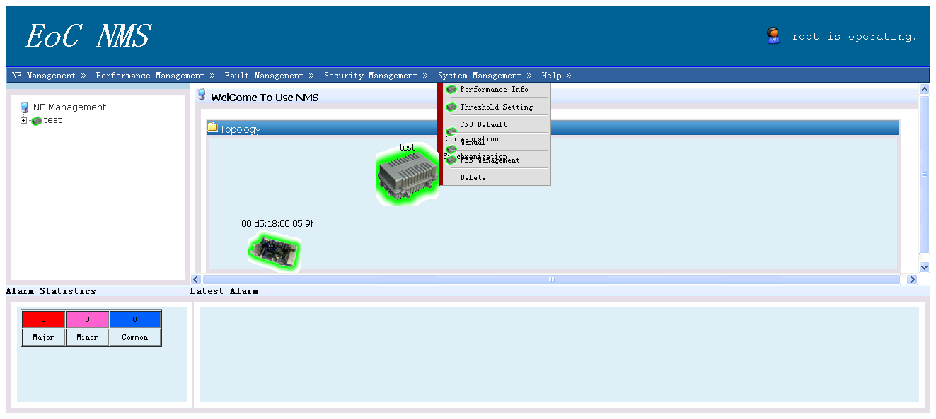

Figure 2.3 View the operation for Master

2.3.1 Master Equipment Property
Use right click the Master which needs management, choose equipment property in the menu, it will show figure 2.3.1.1 interface, and can view the detail information of this Master.
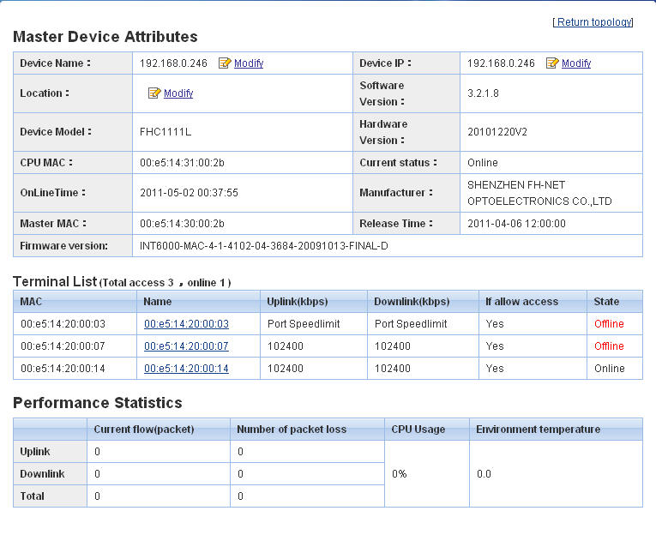

Figure 2.3.1.1 Equipment Property Management Interface

Master Equipment Property:
It includes: Equipment Name, Equipment IP, Location, Software Version, Equipment Model, Hardware Version, CUP MAC, Present Status, FW, Online Time, Manufacturer, Master MAC. User can use <Modify> enter into the Master’s configuration management interface and change the Equipment Name, Equipment IP and Location these general information.

Slaver Lists:
It includes: Access Slaver’s MAC Address, Name, Uplink Limited Speed Value, Downlink Limited Speed Value, Accept Access or not, Present Status. When Slaver’s limited speed mode is port limited speed, the limited speed information shows“Port Limited Speed”, when Slaver’s limited speed mode is whole limited speed, the limited speed information shows the detail limited speed value.

Performance Statistics:
It includes: Current Follow, Package Loss Number, CPU Usage Rate,
Environment Temperature

2.3.2 Configuration Management
You can setting or modify the Master’s parameters through this interface, include seven management interface: General Management, VLAN Management, OqS Management, MAC White Form Management, IP Access Control, Trapserver, Operation Management.

2.3.2.1 General Management Interface
General Management Interface includes: Master’s Name, IP Address, Sub-net Code, Gateway, Position, tftpServer, ntpServer. Users can modify accordingly.
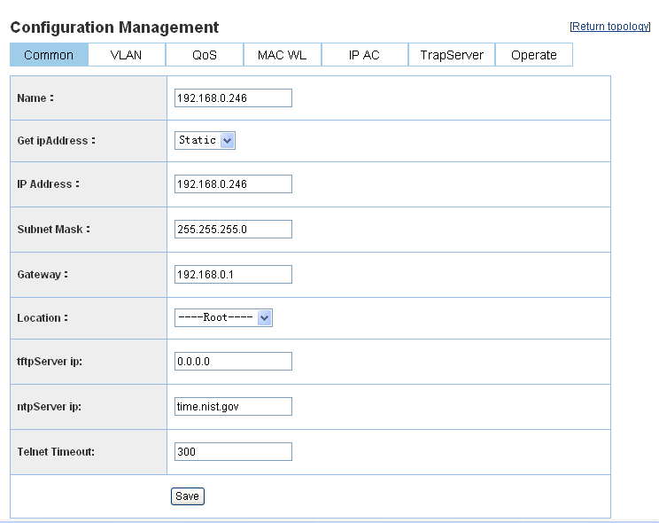
Figure 2.3.2.1 The Master’s General Interface

2.3.2.2 VLAN Management Interface
It includes: VLAN Mode, Manage VLAN. User can modify accordingly.
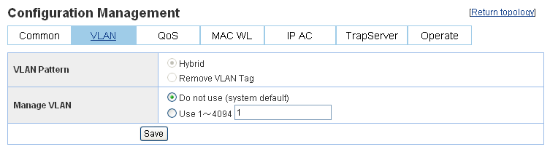
Figure 2.3.2.2 The Master’s VLAN Management

2.3.2.3 QOS Management
It includes: Global Configuration, Qos Work Mode, Advanced Options, Setting Priorities. User can modify accordingly.
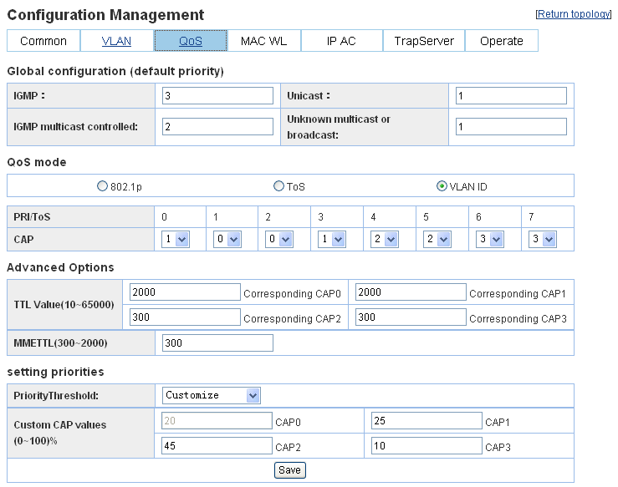
Figure 2.3.2.3 Master’s QoS Management

2.3.2.4 MAC White Form Management
MAC White Form Starts, only the mac address list in white form can access
MAC White Form Close, all the mac can access.

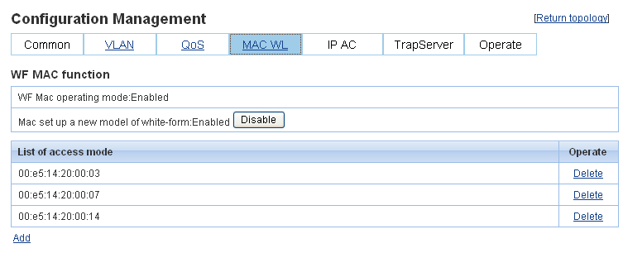
Figure 2.3.2.4 Master’s MAC White Form Management Interface

2.3.2.5 IP Access Control
IP Access Control function default is closed, when this function starts, only IP or IP Segment list in IP Access list can visit the Master.
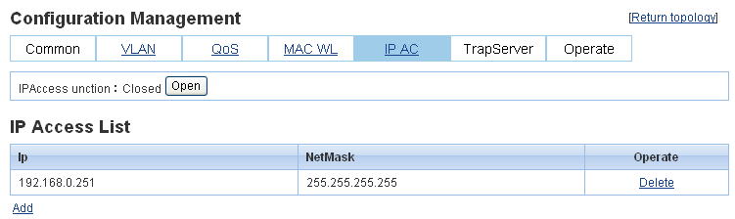
Figure 2.3.2.5 Master’s IP Access Control

2.3.2.6 TrapServer
When user found the Master, EOC NMS Server’s IP address will add into the list automatically, user can add or delete TrapServer accordingly.
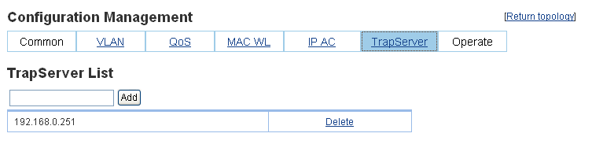
Figure 2.3.2.6 The Master’s TrapServer

2.3.2.7 Operation Management

It includes: Save current configuration, Restart, Restore Factory Settings. User can operate for the Master here.
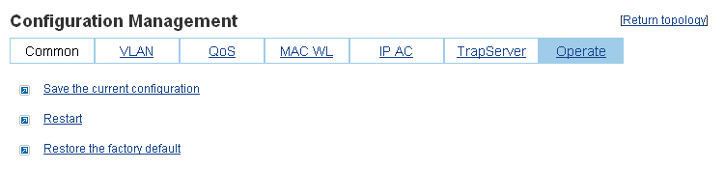
Figure 2.3.2.7 The Master’s Operation Management

2.3.3 Maintenance Operation
As Figure 2.3.3, can start maintenance operation for Master: Save current configuration, Restart, Restore Factory Settings.
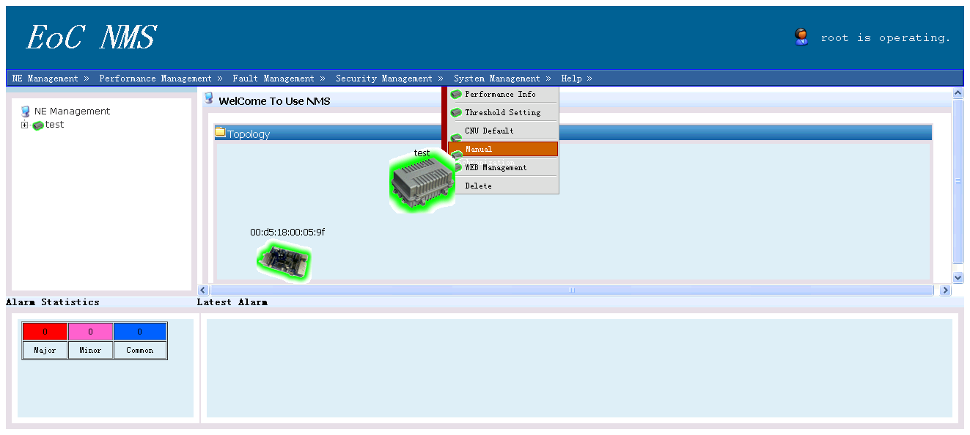
Figure 2.3.3 Maintenance Operation for Master

2.3.4 Fault Management
As follow Figure, it includes: Alarm and Events. Details in 2.6 chapter.
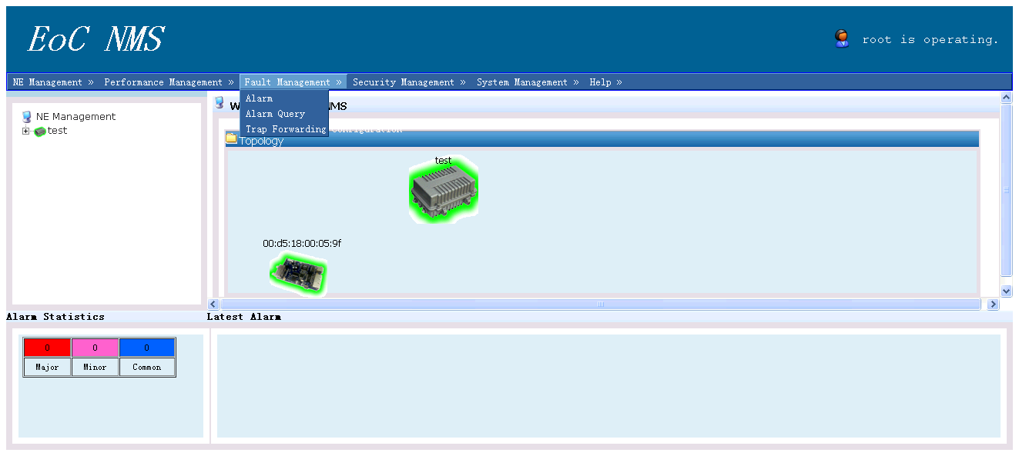
Figure 2.3.4 Default Management for Master

2.3.5 Performance Management
As Figure 2.3.5.1, can view current Master’s parameters and Slaver’s information, also the up/down link speed.

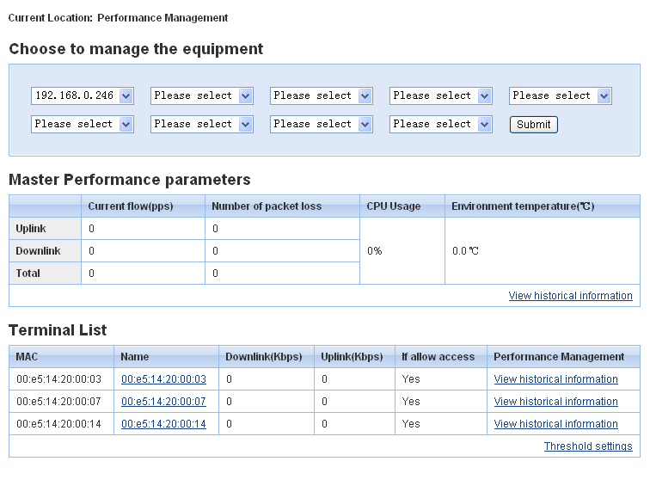

Figure 2.3.5.1 Performance Management for current system
Threshold Setting Interface as Figure 2.3.5.2。
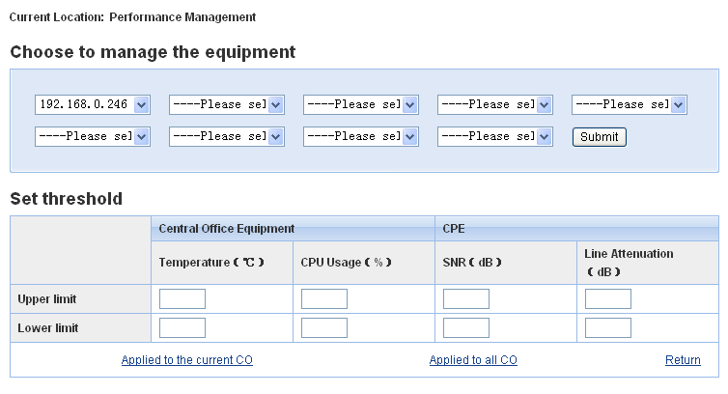
Figure 2.3.5.2 Threshold Setting Interface
Here can set the current Master and application for all the Master.

2.3.6 Check Operation Log
It can check Log documents at any time, includes: System Log, Configuration Management Log, User Safety Log. Default setting is for all the types. User can check Log accordingly. As Figure 2.3.6.1 View Log Information. As Figure 2.3.6.2 can lead-out this interface.
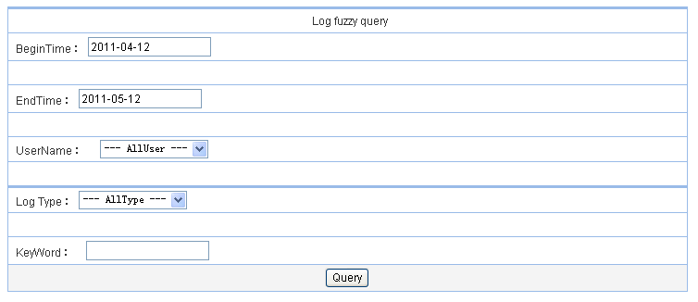
Figure 2.3.6.1 Check Operation Log
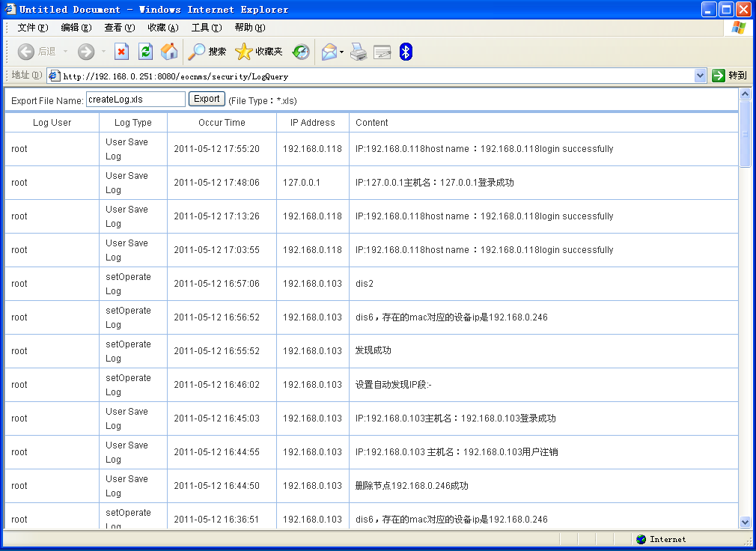
Figure 2.3.6.2 Operate the Log Checking Result

2.3.7 Slaver’s Default Configuration
User can configure new coming Slaver by Slaver’s Default Configuration.
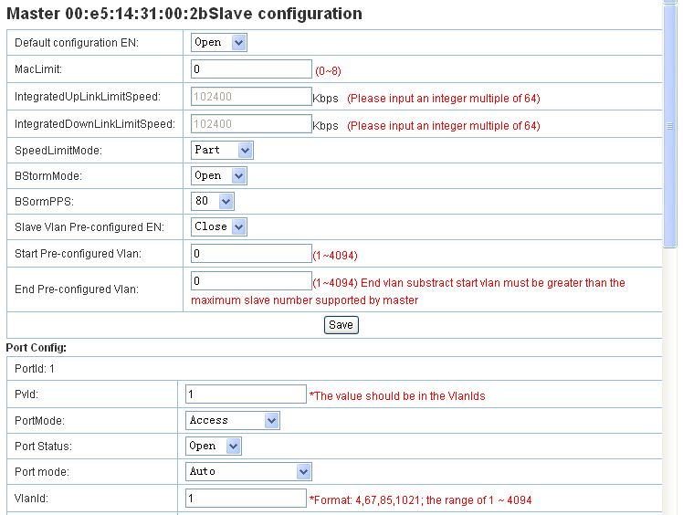
Figure 2.3.7 Slaver’s Default Configuration

2.3.8 Lead-out Data
Lead-out Data function can lead-out current Master and Slaver information to xml document.

2.3.9 Delete Master’s Operation
Use this can delete current Master and Slaver connect this Master.

2.4 Slaver Configuration Page
Use Right Click the Slaver which needs management, as Figure 2.4
User can operate followings for the Slaver:
Property info
Configuration info
Performance info
Delete;

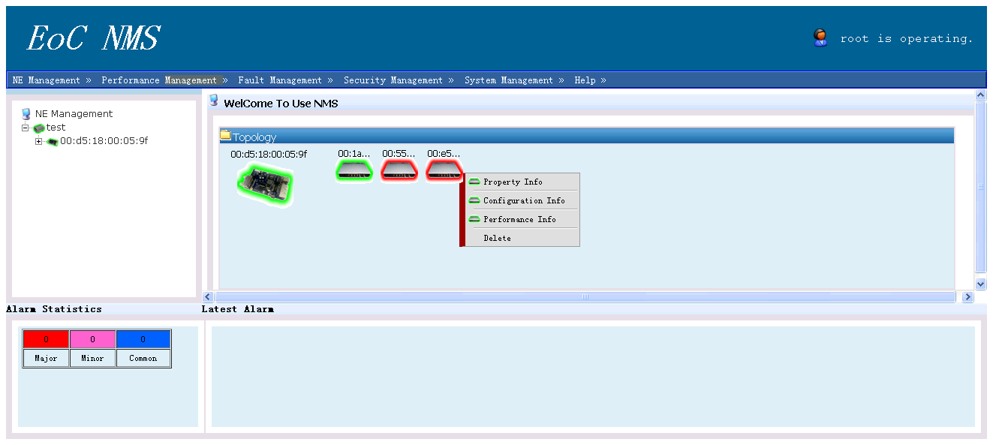
Figure 2.4 Operation for Slaver

2.4.1 Slaver’s Equipment Property
As Figure 2.4.1.1, Use right click the Slaver need to manage, choose Equipment Property in the menu, then user can view as Figure 2.4.1.1, through this interface, you can view more detail information for Slaver.
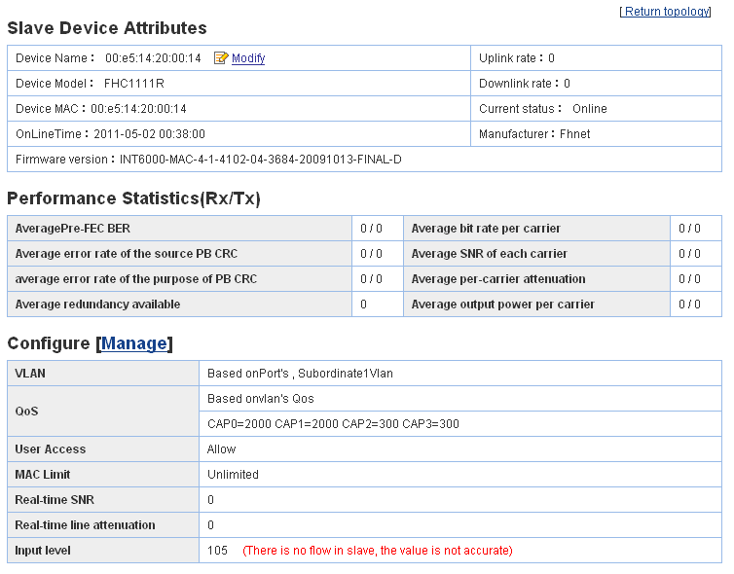
Figure 2.4.1.1 Equipment Property of Slaver
Slaver Equipment Property, it includes: Equipment Name, Equipment Model, Uplink Rate, Downlink Rate, CUP MAC, Online Time, Current Status, Manufacturer, Hardware Version and other information. User can click <modify> enter into Slaver Configuration Management Interface and change equipment’s name and others.

Performance Statistics: it shows current Slaver’s performance statistics data.

Configuration [Management]: It shows current Slaver’s VLAN, QoS, User Access, MAC Control, Real-time SNR, Real-time Line Loss, Port connection Status and other information.

2.4.2 Slaver’s Configuration Management
Through this interface, user can setting or modify Slaver’s parameters, include: General Management, VLAN Management, QoS Management, Broadcast Storm Control, MAC Limit Management, Operation Management. Figure 2.4.2 is the Slaver’s configuration Management Interface.
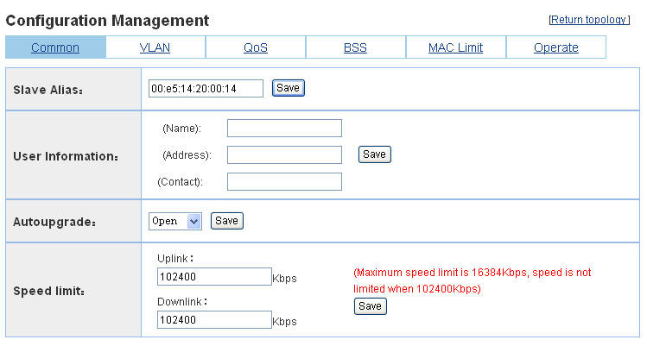
Figure 2.4.2 Slaver’s Configuration Management Interface

2.4.2.1 General Management
In General Management Interface, user can setting Slaver’s name, up/down link limited speed. Different limited speed type with different management interface, limited speed have port limited and whole limited this two types.

Whole Limited Speed:
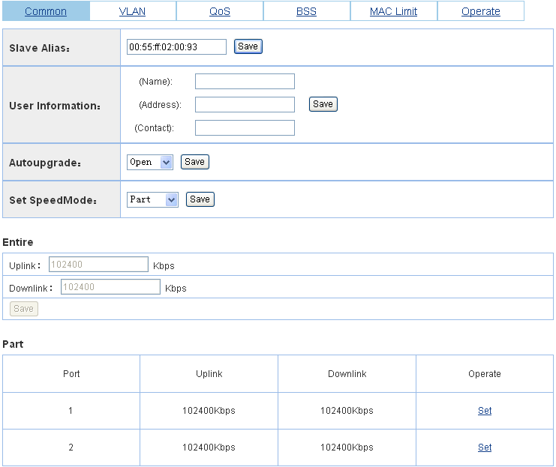
Figure 2.4.2.1.1 Slaver’s General Management-Whole Speed Limited
Port Limited Speed:
Figure 2.4.2.1.2 Slaver’s General Management-Port Speed Limited

2.4.2.2 VLAN Management
Slaver includes support VLAN and un-support VLAN. Figure 2.4.2.2.1 and 2.4.2.2.3, Support VLAN Slaver, just click related port’s “Setting” it will pop-out a page same as Figure 2.4.2.2.2, then configuration PVID,Port Vlan, Mode, also can check current Slaver’s port status in this VLAN Management page, and can close or start port.

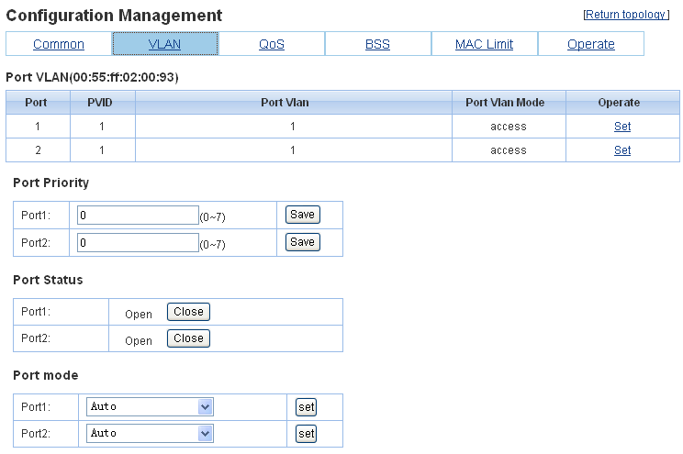
Figure 2.4.2.2.1 Support Configuration VLAN

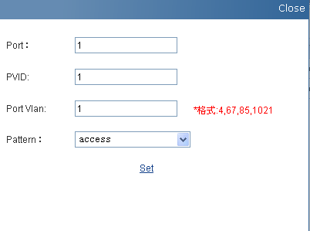
Figure 2.4.2.2.2 VLAN Configuration for support VLAN Slaver

2.4.2.3 QoS Management
Through QoS Management, can set priorities for different Slaver accordingly.

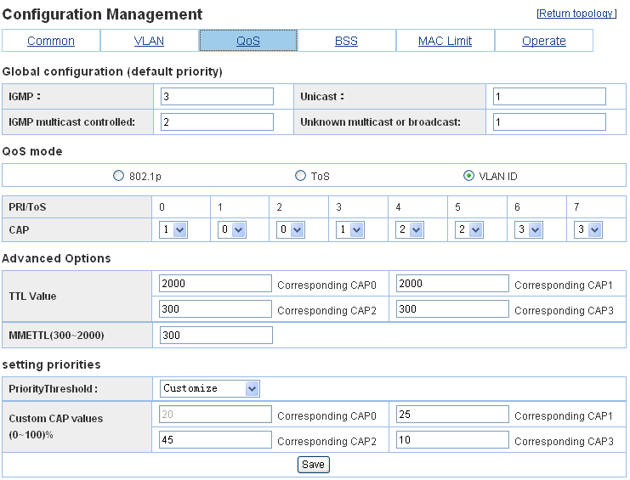
Figure 2.4.2.3 QoS Management

2.4.2.4 Broadcast Storm Control
It includes open/close operation and PPS Value choose.

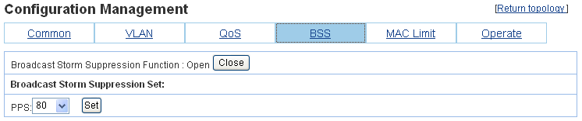
Figure 2.4.2.4 Broadcast Storm Control

2.4.2.5 MAC Management Limit
MAC limit is the PC numbers connect to Slaver.

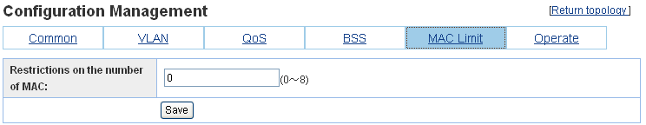
Figure 2.4.2.5 MAC Management Limit

2.4.2.6 Operation Management
Operation Management Interface is the operation for current Slaver: Save current configuration, Restart, Restore Factory Setting, Lead-out Templates.

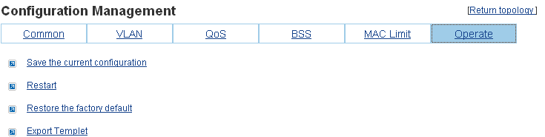
Figure 2.4.2.6 Operation Management

2.4.3 Slaver’s Maintenance Operation
The Slaver’s Maintenance Operation includes: Save current configuration, Restart, Restore Factory Setting, Lead-out Templates.
Templates after lead-out can be checked at【Templates Function】.
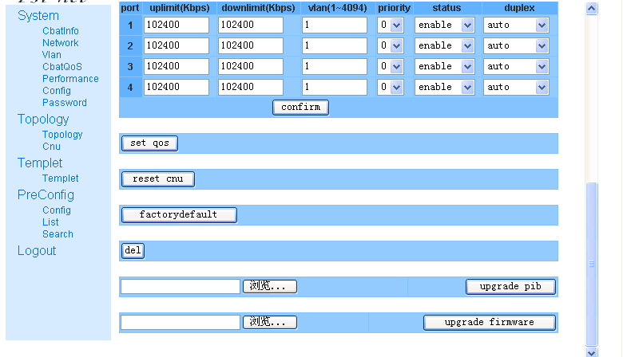
Figure 2.4.3 Slaver’s Maintenance Operation Interface

2.4.4 Slaver’s Delete
Through Slaver’s【Delete】Operation, can delete un-necessary Slavers.

2.4.5 Slaver Replacement
Slaver Replacement is to replace origin Slaver mac with a new Slaver mac, new Slaver’s configuration information is same as origin configuration information, old Slaver replaced by new Slaver, old ones data will be deleted. As Figure 2.4.5
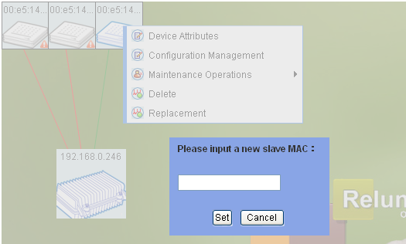
Figure 2.4.5 Slaver Replacement

2.5 Slaver Checking and Master Checking

2.5.1 Slaver Checking
Slaver Checking can check all the Slaver’s information under current Master. As Figure 2.5.1
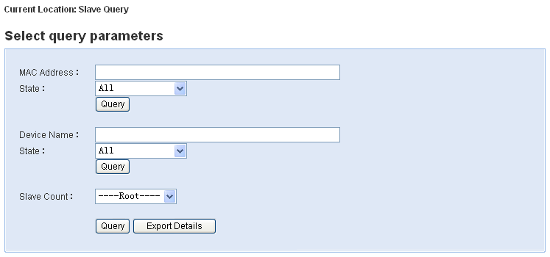
Figure 2.5.1 Slaver Checking Interface
It supports any fragment checking when input Slaver MAC Address, also supports checking through Slaver’s status. Checking result include: Slaver Name, MAC Address, Master IP Address, Status. As Figure 2.5.2
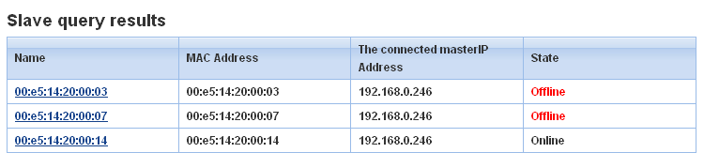
Figure 2.5.2 Slaver Checking Result
Choose the drop-down list of Slaver’s number counting, then click<Execute Query> count the Slaver’s quantity in this region.

2.5.2 Master Checking
Master checking and Slaving checking is similar. Just input Master’s MAC Address or IP Address in Figure 2.5.3. Checking result refer to Figure 2.5.4. Also can count the Master’s quantity in this page for different region.
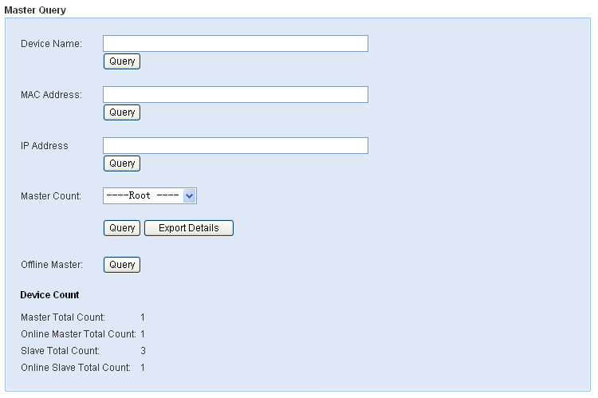
Figure 2.5.3 Master Checking Page
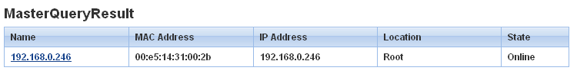Figure 2.5.4 Master’s Checking Result

2.6 Alarm and Events
Click Alarm and Events in Guide-line, then can check the whole system’s Alarm and Events’ Information

2.6.1 Alarm
As Figure 2.6.1.1, it is Alarm information page. Alarm Information has two type: Alarm Information List and Charts. It can show all the Alarm Information also can show present Alarm Information.
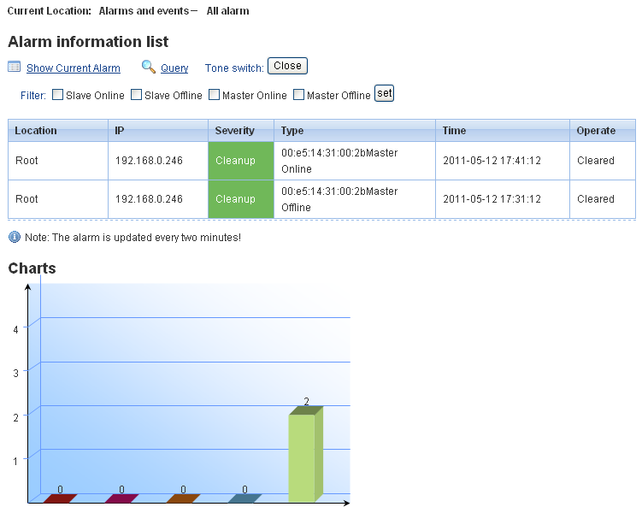
Figure 2.6.1.1 Alarm Information Page
If user want to check Alarm Information by one detail IP or one detail time or importance level, just click upper right side <Checking>, then can check any Alarm Information accordingly. As Figure 2.6.1.2

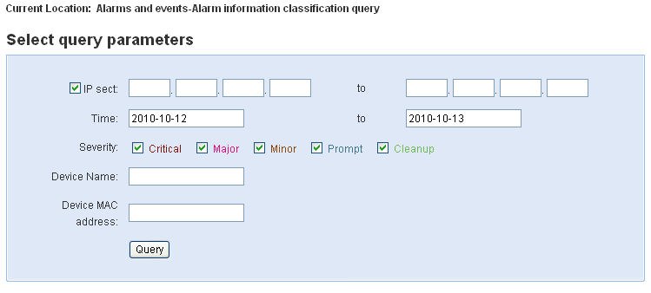
Figure 2.6.1.2 Alarm Checking Page

2.6.2 Events
As Figure 2.6.2 is the Events’ Management, Events reflect the system information not enough for Alarm record.

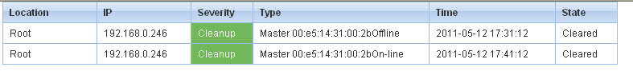
Figure 2.6.2 Event Checking Page

2.7 Performance Management
As Figure 2.7.1, this is Performance Management Page, it can choose different region’s Masterby drop-down list menu, then monitoring the performance.
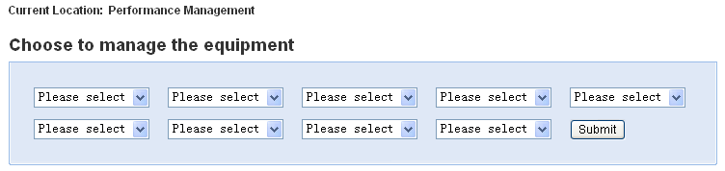
Figure 2.7.1 Performance Management Checking Page
Choose a designated location Master and “Submit”, then can check present Master’s Performance Parameters, related Slaver’s basic information, and connected Slaver’s transmission rate. As Figure 2.7.2
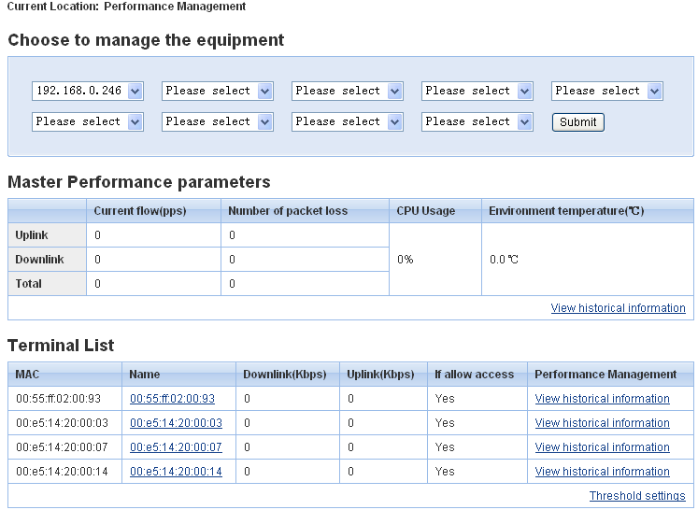
Figure 2.7.2 Performance Management Monitoring Page
For checking history record as Figure 2.7.3 and 2.7.4, supports lead-out Master and Slaver’s history information.
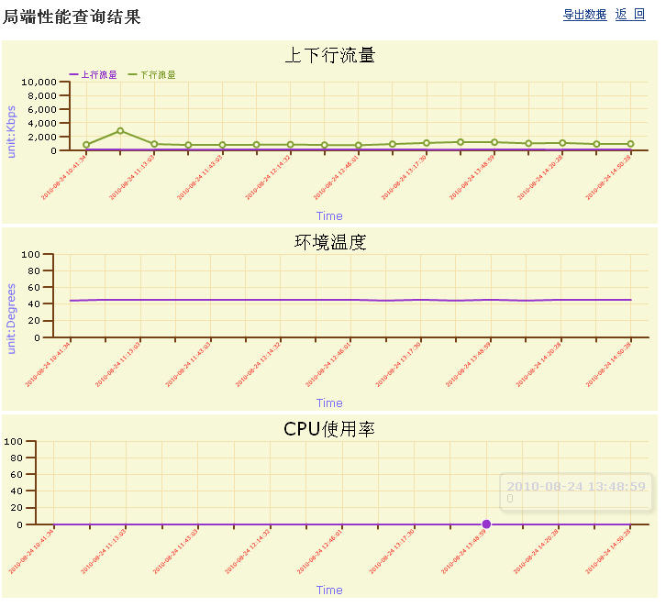
Figure 2.7.3 Master’s History Information Page
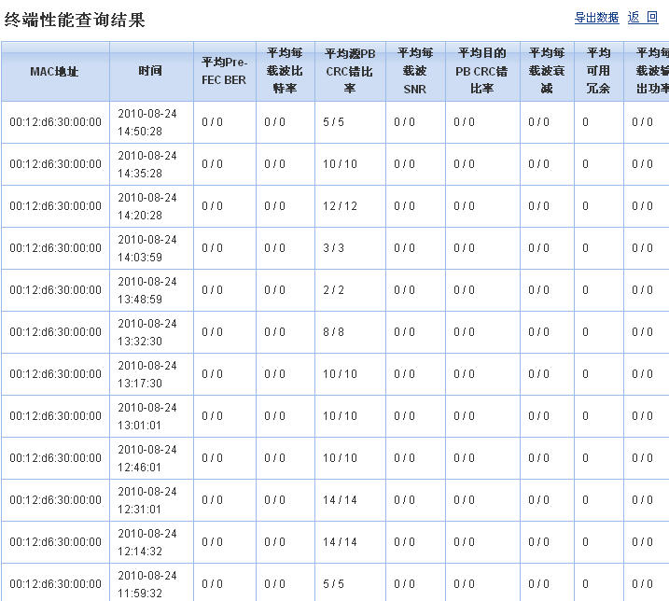
Figure 2.7.4 Slaver’s History Information Page

Threshold Setting Page as Figure 2.7.5
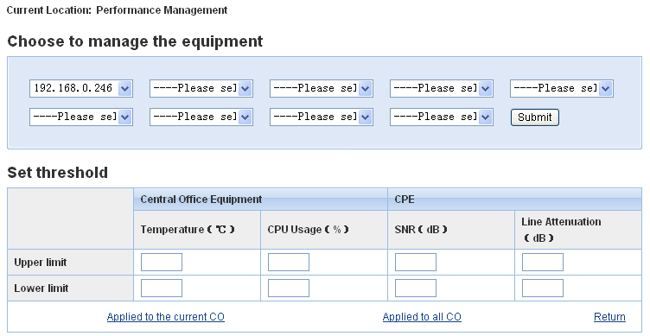
Figure 2.7.5 Threshold Setting Page
Here can setting application for present Master or all Masters.

2.8 Security Management

2.8.1 Basic Information
Figure 2.8.1 is user information management page, it can help to add user’s information.
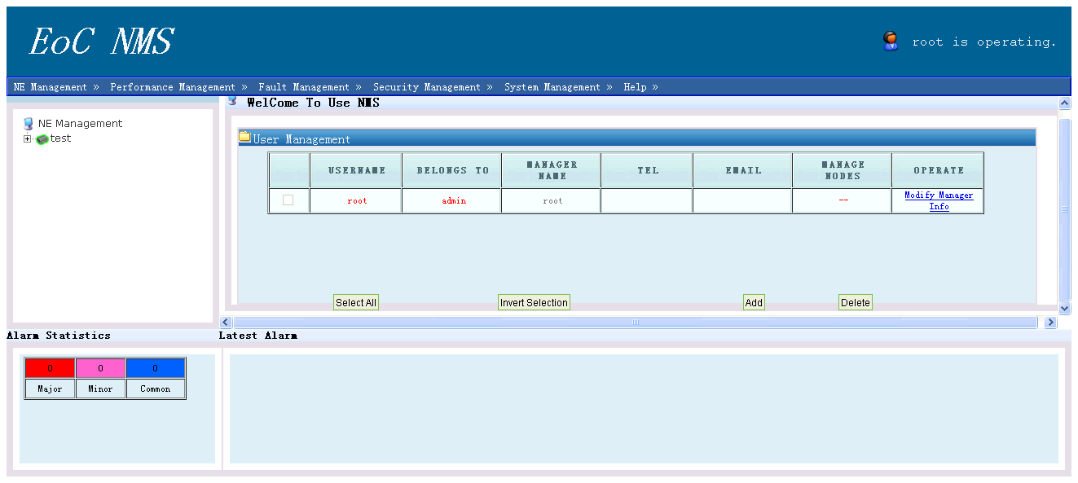
Figure 2.8.1 Basic Information Modify

2.8.2 Change Password
Figure 2.8.2 is the user’s page for changing password.

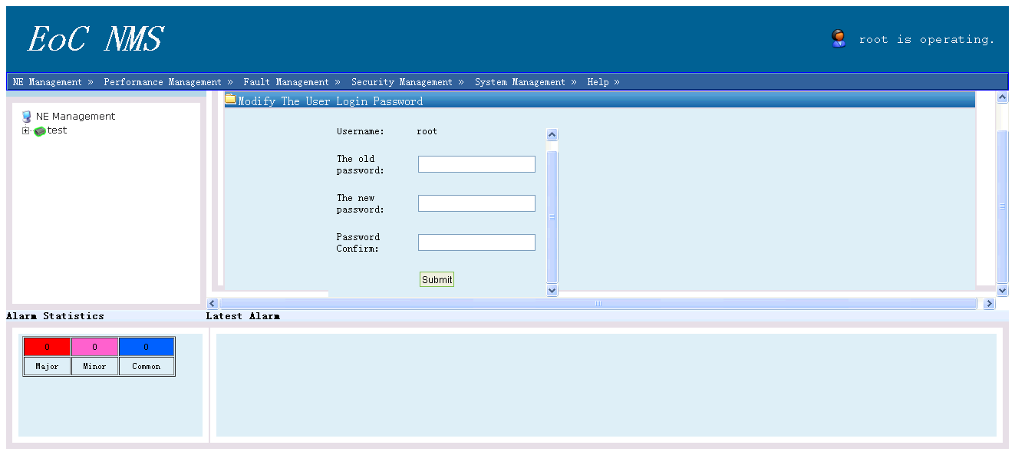
Figure 2.8.2 Change Password

2.8.3 User Management
As Figure 2.8.3.1 is the main page for User Management.

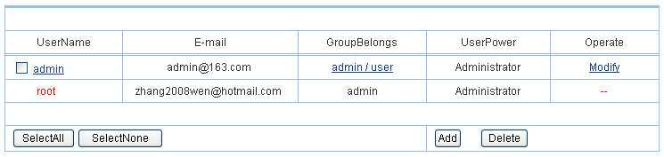
Figure 2.8.3.1 User Management
Click <Modify> enter into User Information Modify Page. As Figure 2.8.3.2:

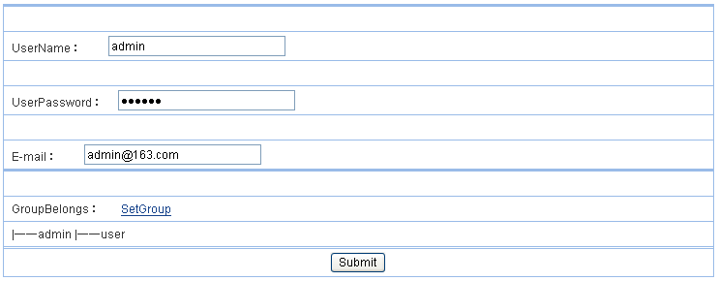
Figure 2.8.3.2 User Information Modify
When needs modify the user’s group, click the related group link to modify the group information. As Figure 2.8.3.3

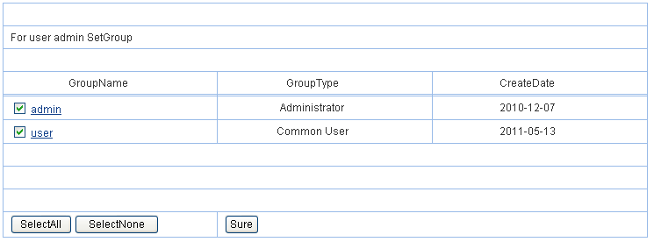
Figure 2.8.3.3 User Setting Group
Click <View> of User Rights List in User Management Page, can view the user’s rights information. Only the user ”root” have the rights to modify other user’s information. As Figure 2.8.3.4
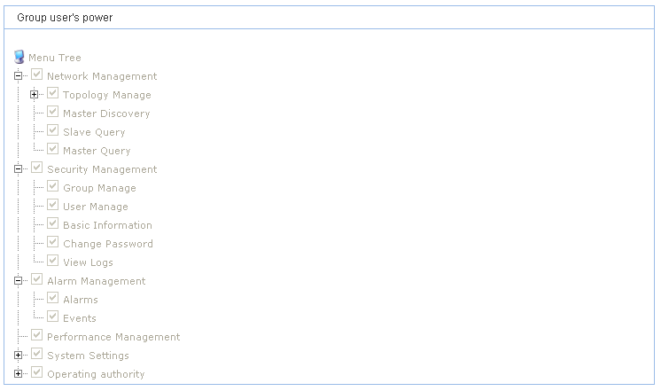
Figure 2.8.3.4 View Groups’ rights

2.8.4 Group Management
EoC NMS divide Operation User into different four level group, they are: System Management User, System Maintenance User, System Operation User and System Surveillance User. It also can divided accordingly. Figure 2.8.4.1 is Group Management Page.

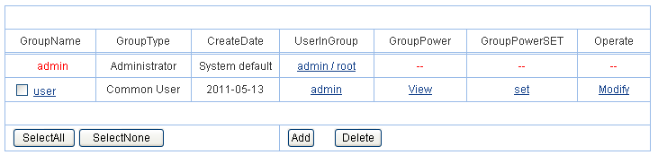
Figure 2.8.4.1 Group Management
System Administrator can set group rights accordingly. Group Name’s Modify please click operation list’s modify link. As Figure 2.8.4.2 Group basic information modify.

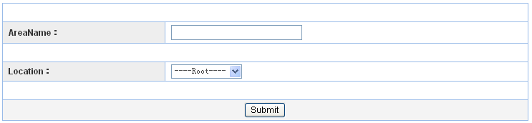
Figure 2.8.4.2 Group Basic Information Modify

2.8.5 View Log
For user’s convenience, the system offers Log function. Figure 2.8.5 is Log checking Page.

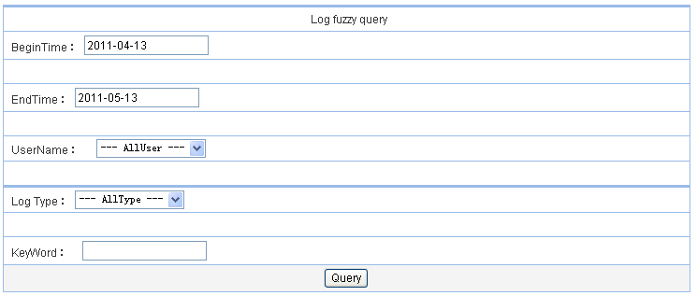
Figure 2.8.5 Log Checking Page
Figure 2.8.6 is the example of Log Record Information. Includes: Log User, Log Type, Time, IP Address, Content, also supports Logs lead-out function.

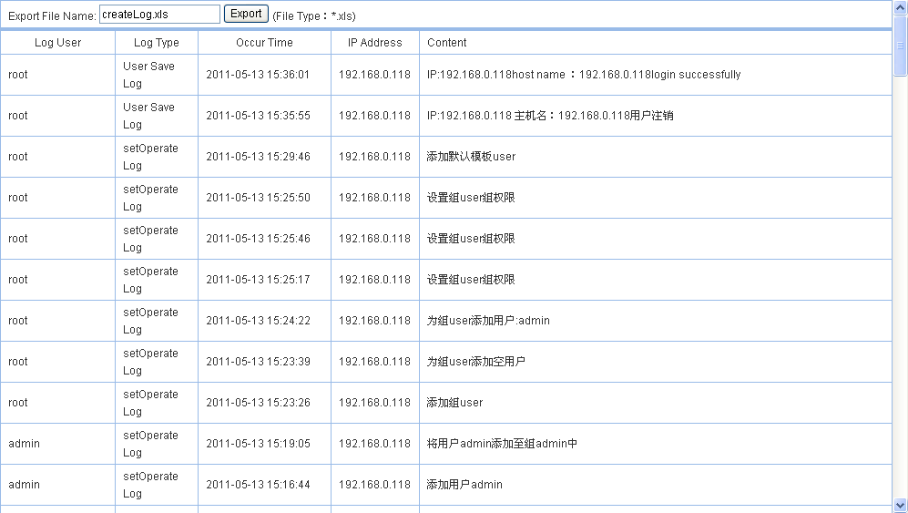
Figure 2.8.6 Logs record information

2.9 System Setting

2.9.1 System Parameter Settings
Figure 2.9.1 is the System Parameter Setting Page. Through this page, user can backup for database, backup time for database, Equipment Name and others.

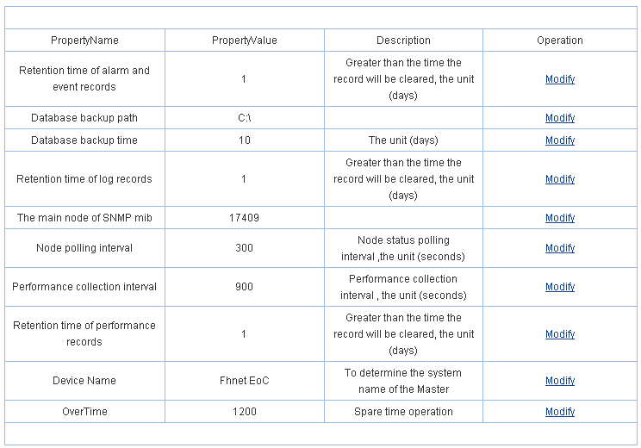
Figure 2.9.1 System Parameter Setting

2.9.2 Region Setting
Region setting offer “Select All”, “Anti-election”, “Add”, “Delete” option and set for region. Figure 2.9.2 is Add Region Page.

Figure 2.9.2 Add Region Page

2.9.3 Template Function
Template Function used for a set-done Slaver information configurate quickly to others Slavers. User just lead-out the Slaver has been set in Slaver List as Template A, then copy Template A to other Slavers. User also can click < Add Default Template> for Customerized Template. Template function as Figure 2.9.3

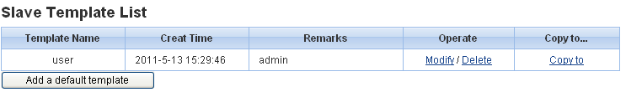
Figure 2.9.3.1 Template Function

Click <Modify> can change the Template’s content.
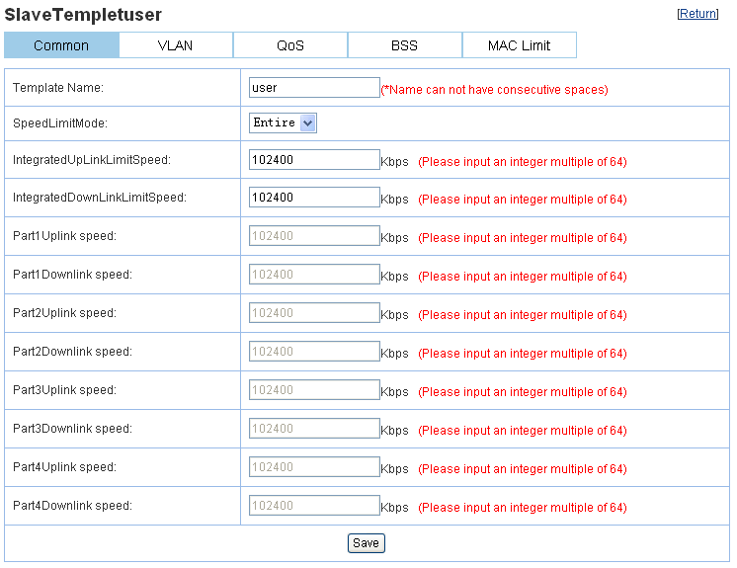
Figure 2.9.3.2 Modify Template
Click <Copy To> under the Template of Slaver Template List enter-into Template Configuration Page, then choose the Slaver need configuration, choose <Start Configuration>, As following Figure:
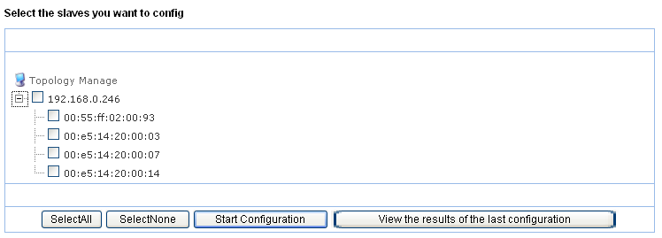

2.9.4 Global Configuration
It’s used to configure the data of Global Configuration List for all the new access Slavers in this Management System.
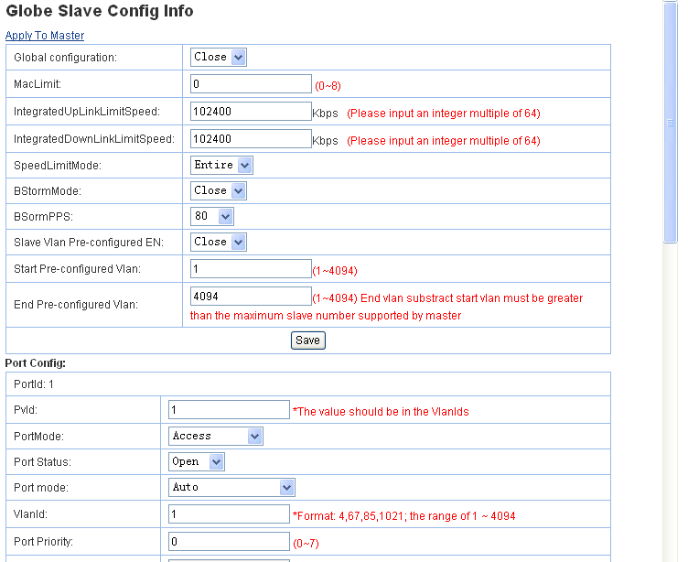
Figure 2.9.4 Global Configuration Information

2.9.5 Slaver Pre-configuration
Add un-registered Slaver, it’s for add Slaver at any MAC Address into the list, if this Slaver on-line, then configure this Slaver with selected Template.

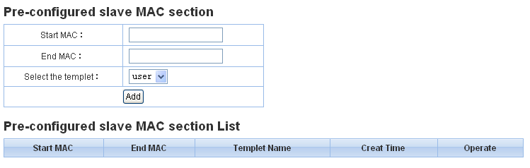
Figure 2.9.5 Slaver Pre-configuration

2.9.6 Database and Backup Recovery

2.9.6.1 Backup Database
It is used to deal with the current database backup and input backup document’s save direction and database name. As following Figure:
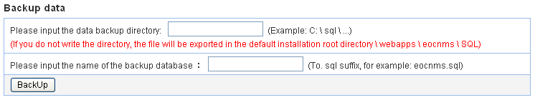
Figure 2.9.6.1 Database Recovery

2.9.6.2 Database Recovery
It is to lead-out existing database into present database. As following Figure:
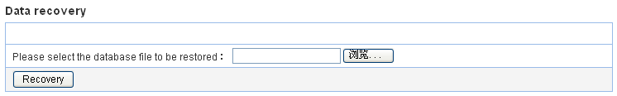
图2.9.6.2 恢复数据

2.9.6.3 Data Migration
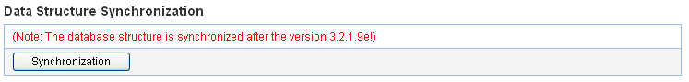
Figure 2.9.6.3 Data Migration

2.9.7 Master Upgrade
It can upgrade single or multi Master Equipment through Master Upgrade, Master Upgrade needs FTP Server, see following:
